1. **Pre-info**: In this lecture, we will create **anonymous volume** so maybe, the command will not work in Git Bash but it will work in CMD. To see the difference you can run the command 🡺 docker inspect <container-id-or-name>
2. How to add a volume to a container?
3. There are two ways
4. Let’s try the first way which is by adding **VOLUME command in Dockerfile file**.
5. **Adding an instruction to a Dockerfile**:
6. 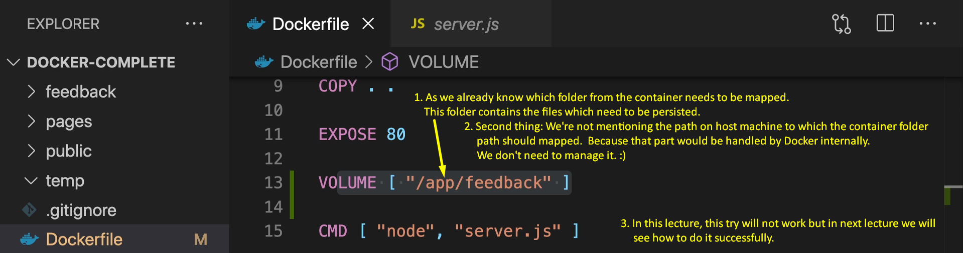
7. Graphical user interface, text

   Description automatically generated
8. Graphical user interface, text, application

   Description automatically generated
9. Text

   Description automatically generated
10. 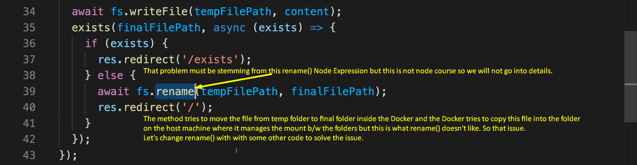
11. Text

    Description automatically generated  
      
      
    Graphical user interface, application

    Description automatically generated  
       
      
    